## Deepak

* Correlation between age and treatment

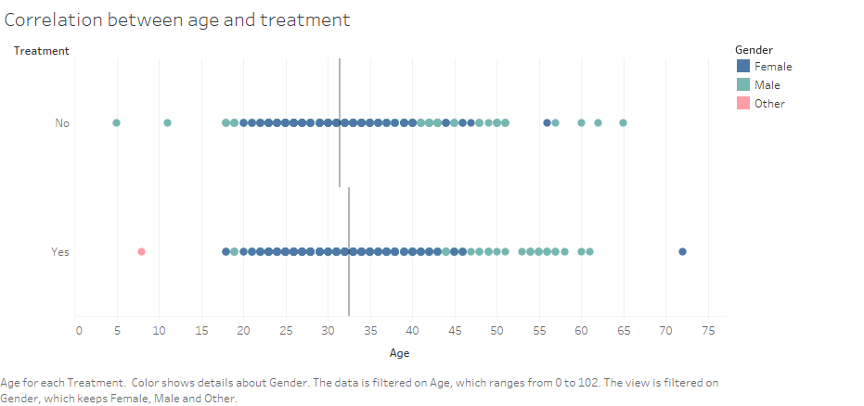

* Contingency Map showing how likely Employees are willing to discuss a Mental Health issue with Coworkers/Supervisors

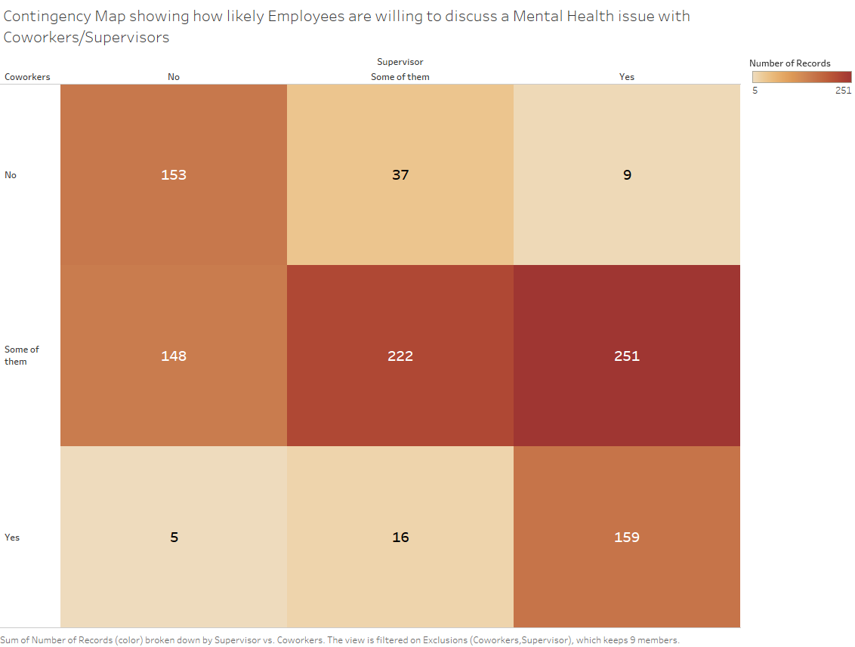

* Graph showing Age/Gender distribution of people who have observed negative Mental Health Consequences at the Workplace

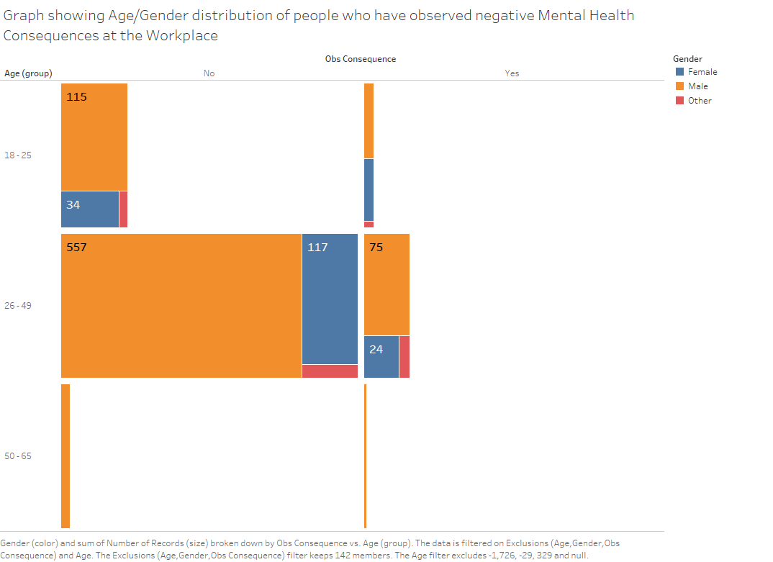

**Anika**

* Geography vs Care options

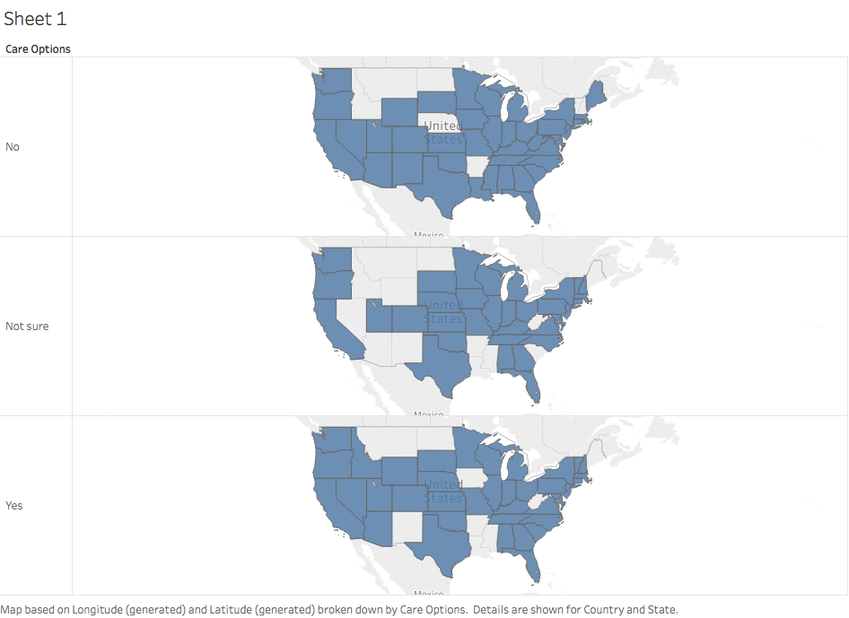

Work Interference

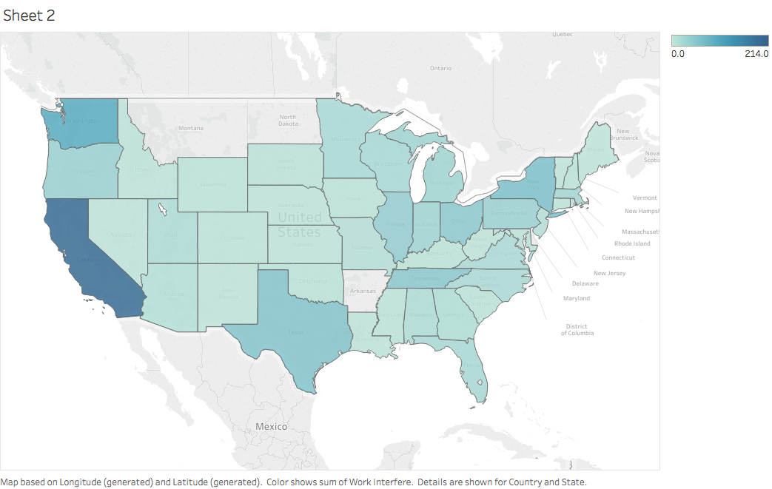

male

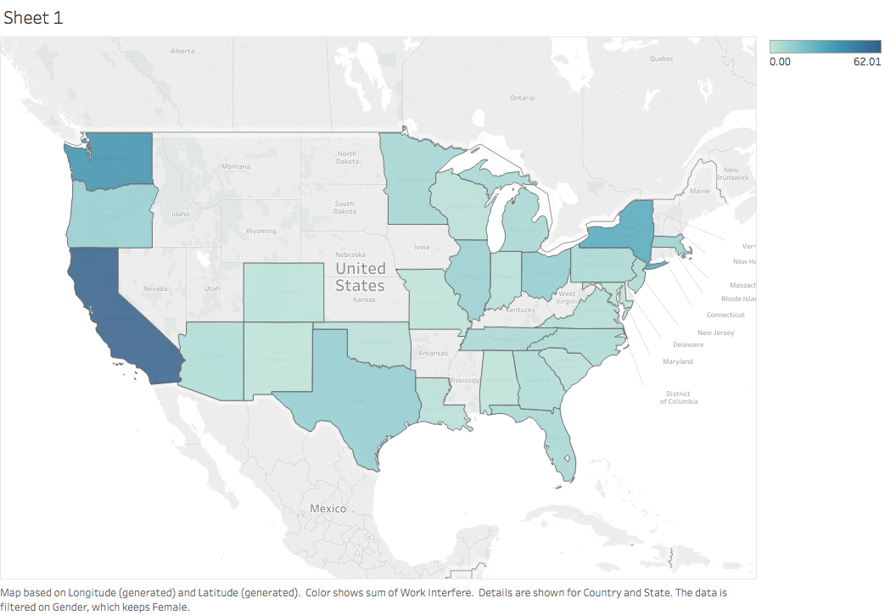

female

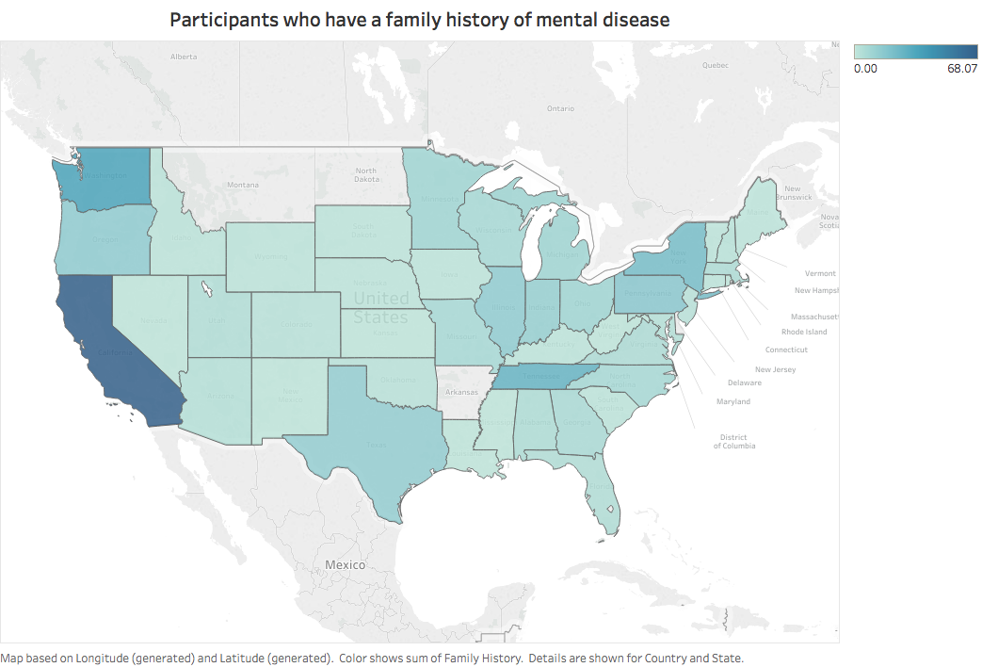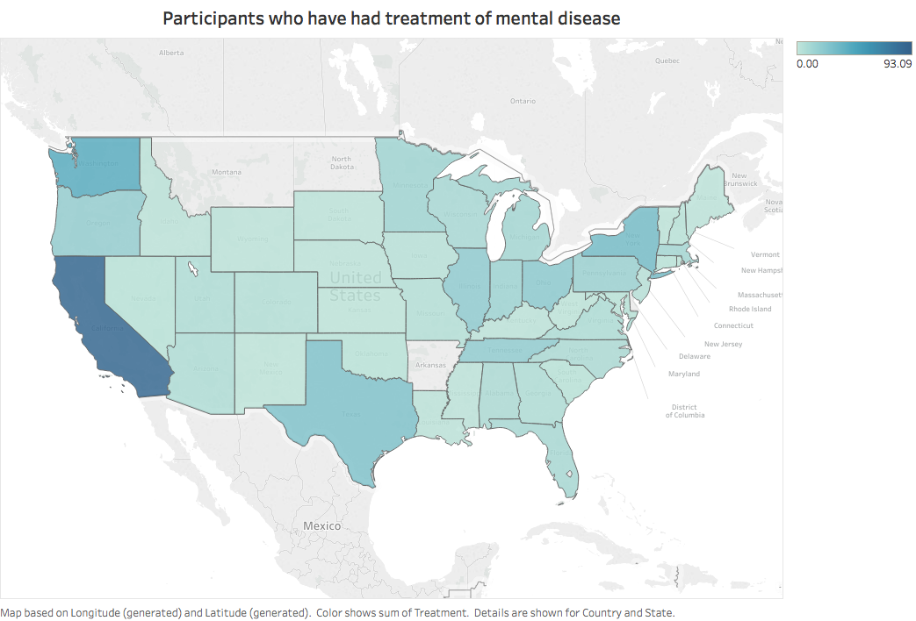

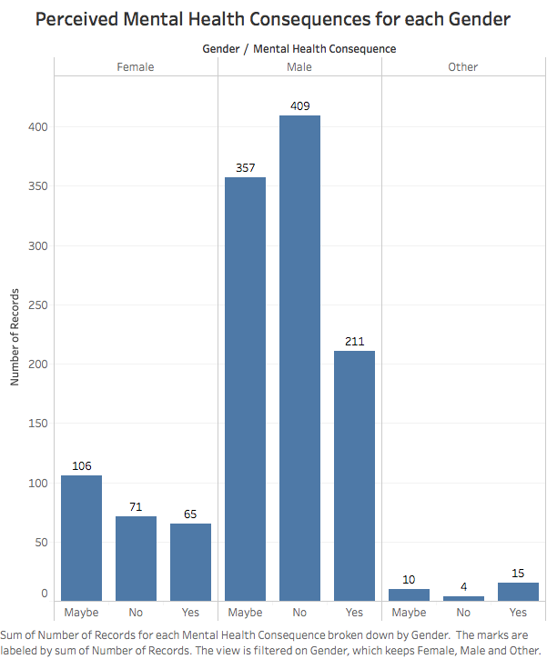

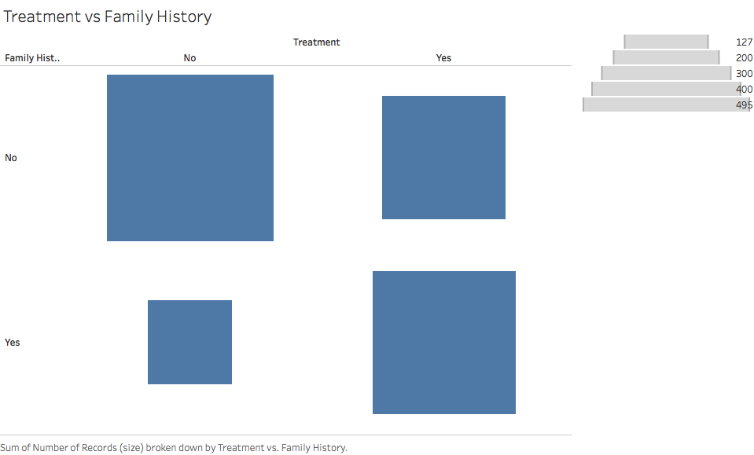

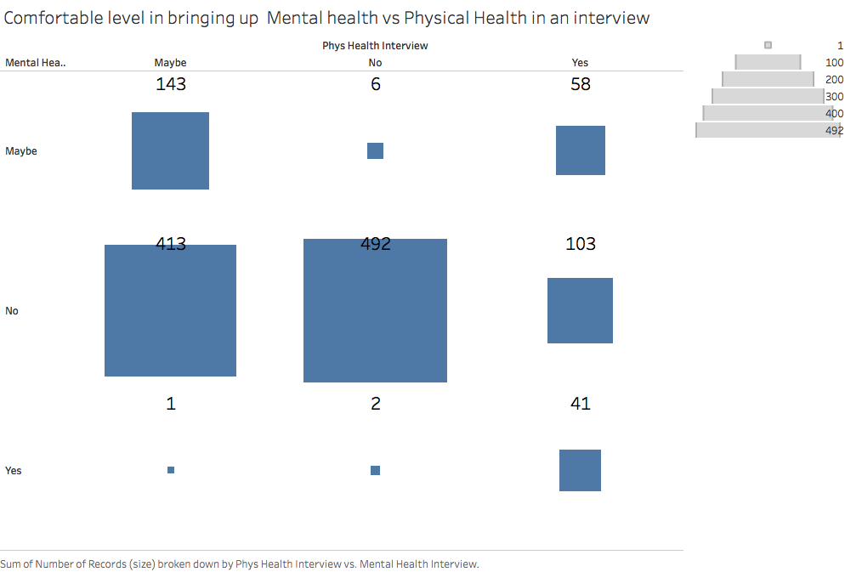

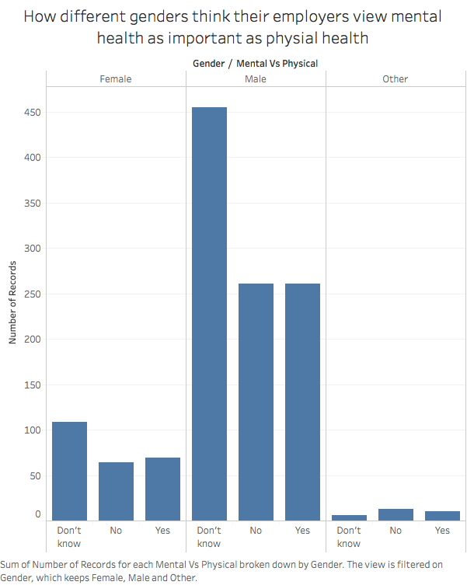

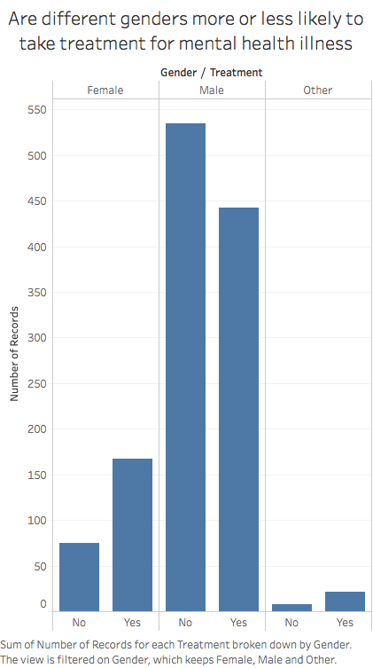

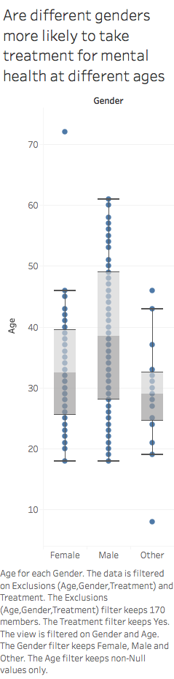

**Jaymin**

The graph below shows what is the effect of age and gender on the person who seek help regarding mental health. It is visible that average for female seems slightly higher than males who seeks help.

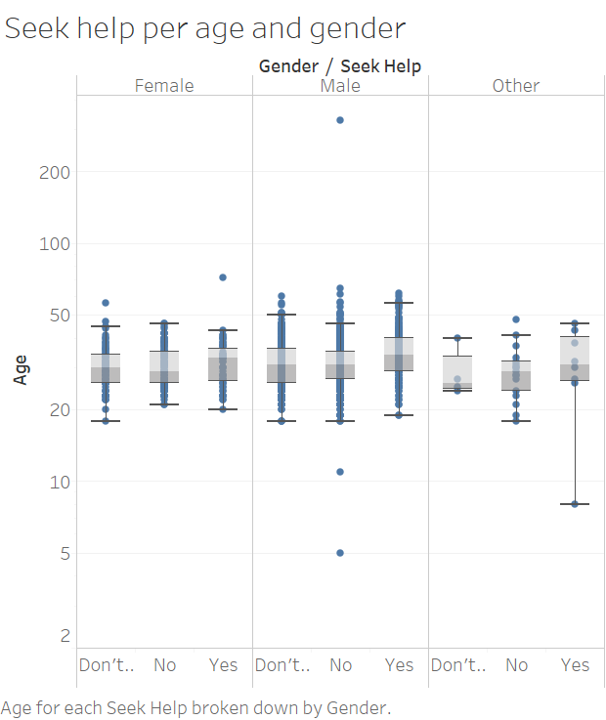

People are getting more leaves in states where people are having high mental health consequences. Color shows number of total leaves in a state and the labels for each state describes how many people have mental health consequences.

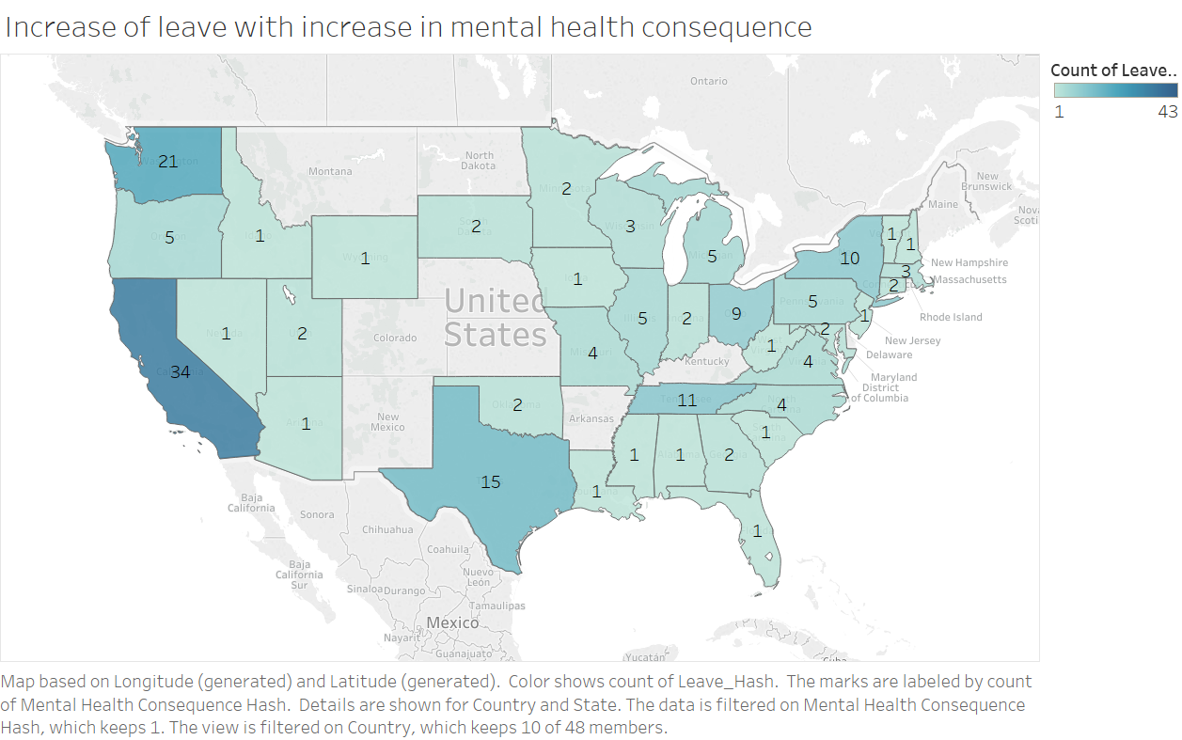

Graph shows the relationship between whether the people work remotely and if they need treatment state wise. California is the state where more people work remotely and may be that is the reason they require treatment for the mental health.

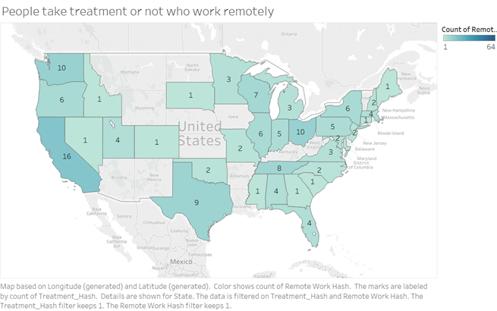

This graph shows a clear relation between what are the reasons a person is getting mental health treatment. Though, it seems that there are more people who gets treatment even though they don’t have any mental or physical health consequences or they are observed for any kind of consequences. That thing seems fishy to me.

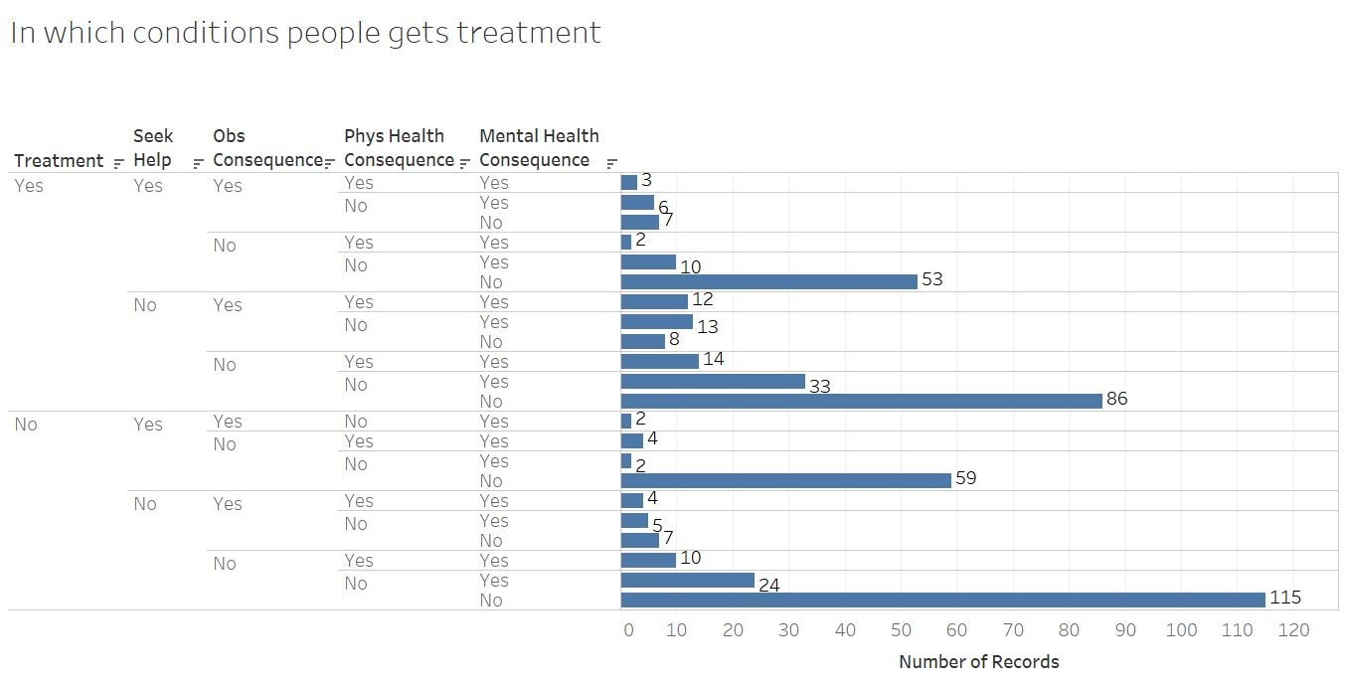

Treemap shows people who seek help state wise. And from the graph it is clear that California is the state where there are more people who seek help for their mental health.

